Evan Smith

CSE 644, Internet Security

Lab1

**Task 1.1A**

Code to do basic sniffing:

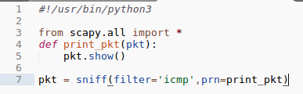

With Root Privilege

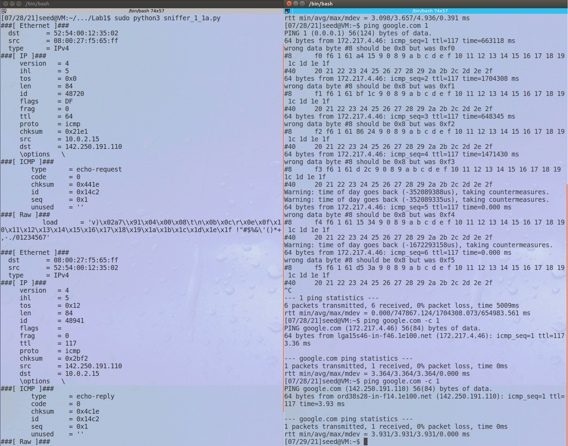

Without Root Privilege:

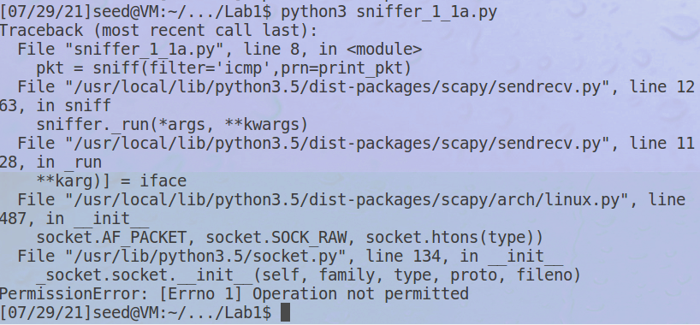

We see that with the root credentials, we can listen to the raw input of the card. Without root, we are blocked from opening a socket and therefore cannot grab the traffic from it.

**Task 1.1b**

Code to capture only the ICMP packets:



Output of the sniffer with this filter:



Code to capture TCP packets from a certain IP into a certain port:

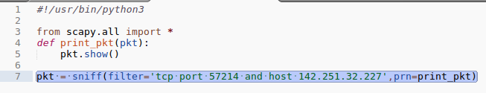

Output of the sniffer with this filter:

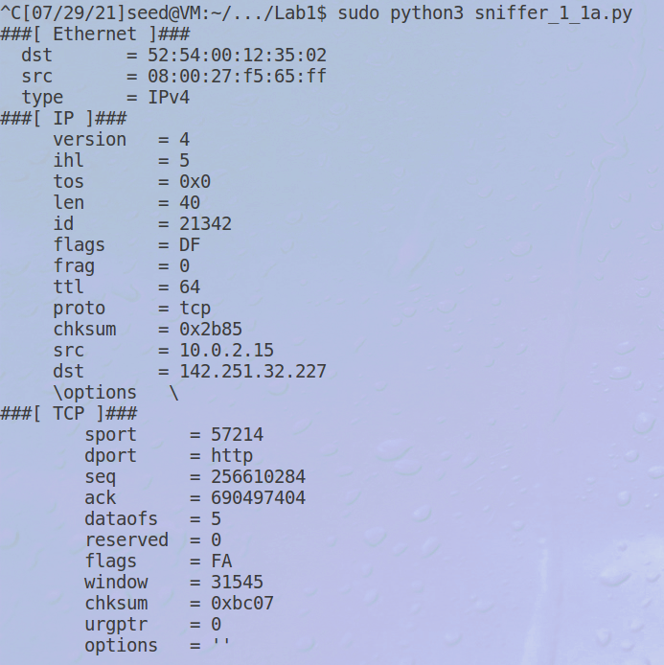

Code to capture packets from a certain subnet:

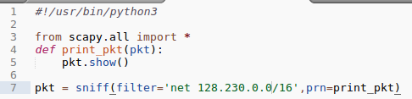

Output after pinging an IP in the chosen subnet:

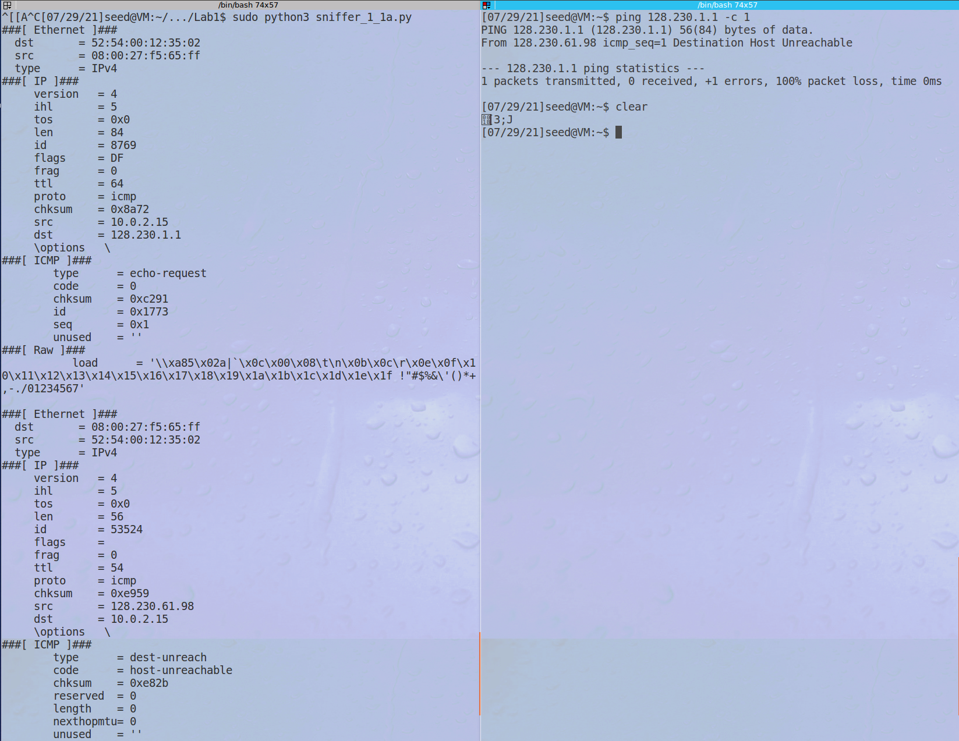

Observations: We can receive as broad or as narrow of packets as we want using the sniffing program with very little alteration to the base code.

**Task 1.2: Spoofing ICMP Packets**

Code to spoof the packet:

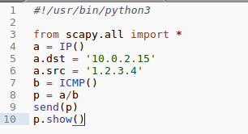

Output in Wireshark, showing that the spoofed packed shows as being sent from IP 1.2.3.4, when it was actually sent from the same VM:

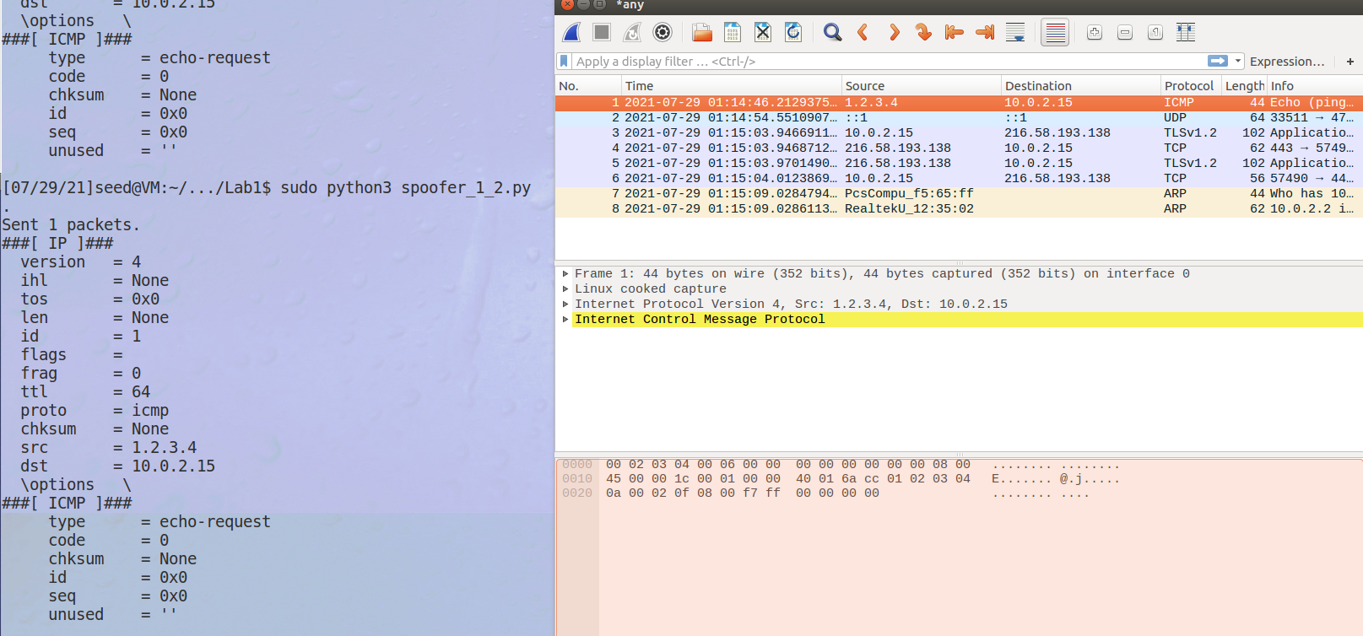

**Task 1.3: Traceroute:**

My code to execute the traceroute:

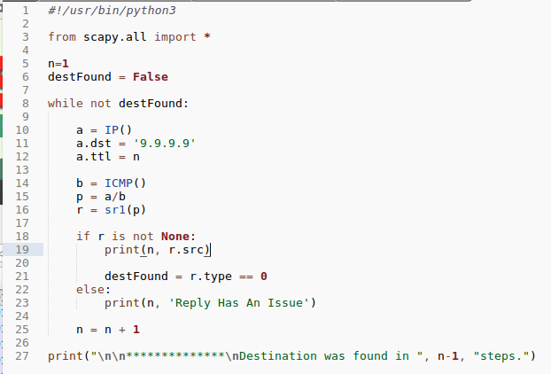

The output of the code:

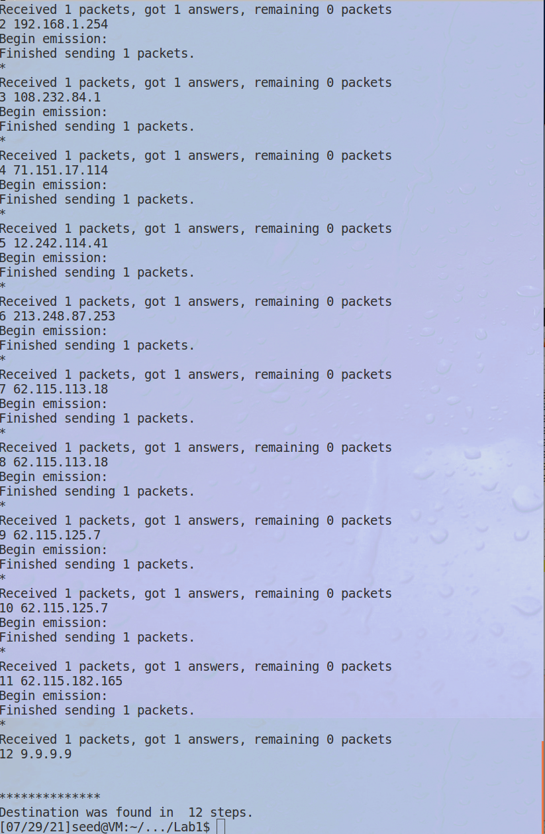

Notes: We can see that it took 12 routing points to make it from my VM to the target address of 9.9.9.9. This value was consistent when I was testing the code, but it is important to note that the IP addresses that come up as the steps in between could easily change over time, and the total length of the routing path itself could be much longer or shorter as well.

**Task 1.4: Sniffing and Spoofing:**

The code for snoofing:

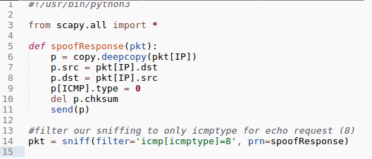

The ping from the other VM to 10.0.1.3 without the snoofing running:

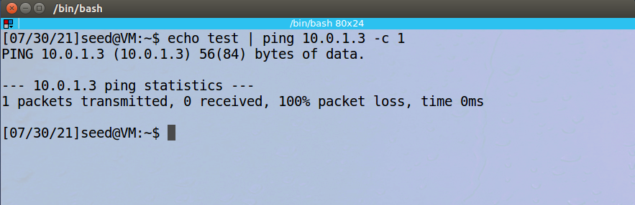

The ping from the other VM to 10.0.1.3 WITH the snoofing running:

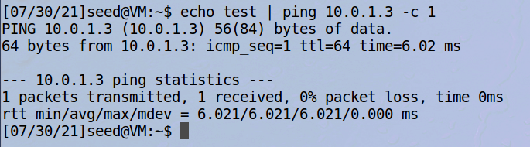

Observation: With the snoofing program off, dead IP addresses returned no packets to the host pinging them, but we were able to successfully intercept the requests and inject false responses. An interesting point is that I had trouble getting the checksum to be correct for the fake responses, and Wireshark still doesn’t like it. However, the ping utility seems to accept the response with no issues.

**Task 2.1a: Writing Packet Sniffing Program**

The code for the basic C sniffer program (from lab webiste):

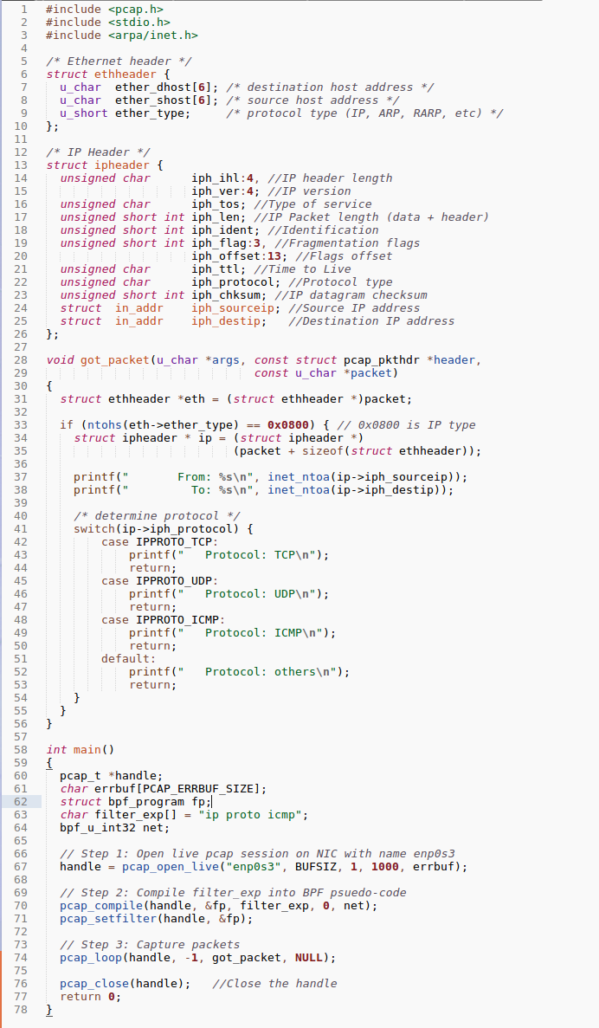

Output of the program from simply opening Firefox:

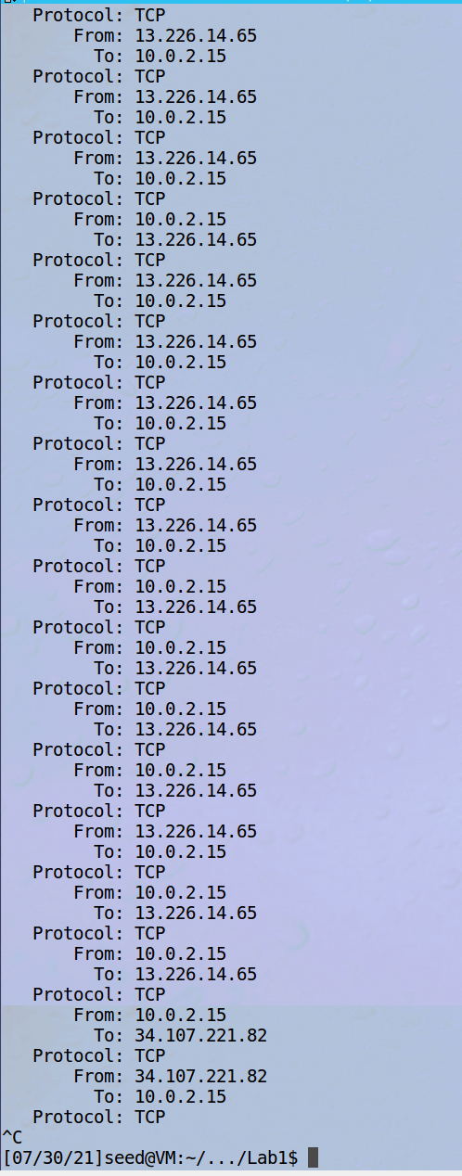

**Observations**: We are able to gather the same information using the C program as we were in Python. The filter on this version is very broad, so we are seeing both TCP and UDP packets being registered. It was required to run the command with sudo to prevent segfaults.

**Question 1:** The calls needed for a sniffing program are the one to open up a socket (here its pcap_open_live), then a filtering step to funnel the input, and finally a listening step or loop that actually grabs packets from the socket based on the filter.

**Question 2:** We need the root privilege to run sniffers because we need to be allowed to open our own sockets to listen on. Without root privilege, the program fails at the pcap_open_live function, which is where we begin to interact with the socket directly.

**Question 3:** With promiscuous mode on, the sniffer is able to see and report on all traffic that fits the filter passed in, even if it isn’t directed at the host that is running the program. Without promiscuous mode, the sniffer will only report on packets directed to the specific host.

**Task 2.1B: Writing Filters:**

Using filter 1 to receive only ICMP packets between my two VMs:



Output:

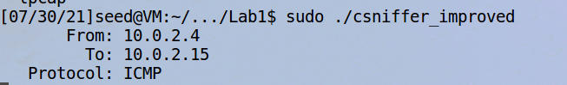

Using filter 2 to receive only TCP packets with ports between 10-100:



Output of the NetCat connecting VM and the sniffing VM – note that the netcat made 5 requests but only 2 were valid, and we see only 4 sniffed packets (two per request):

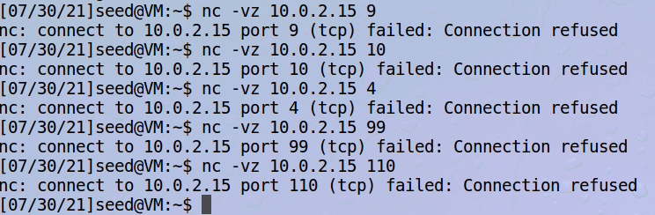

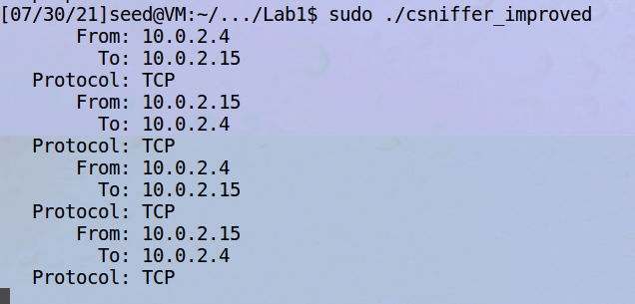

**Task 2.1C – Sniffing Passwords:**

Code changes to the got_packet function and filter to get telnet inputs only:

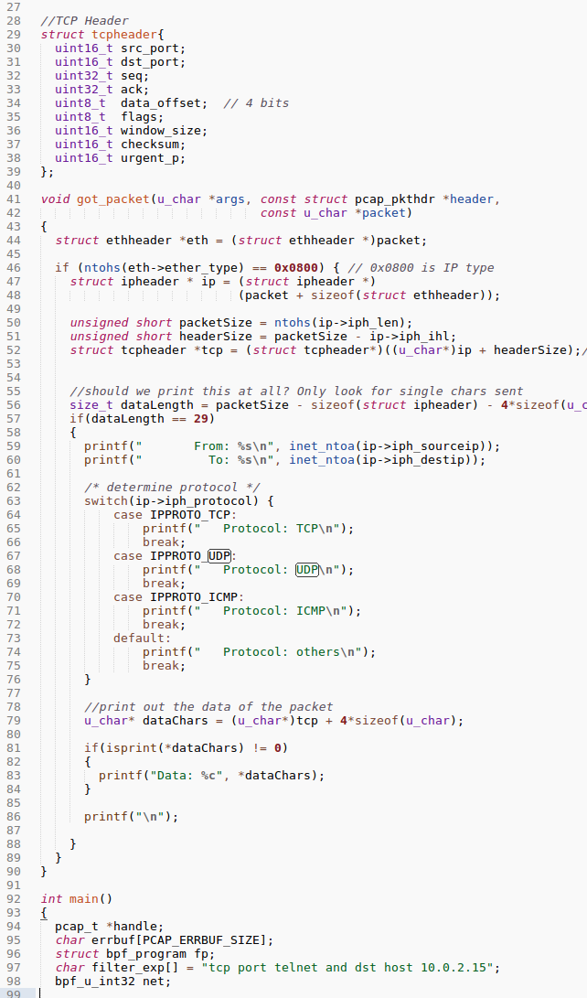

Telnet screen from separate VM (username *user*, password *password*):

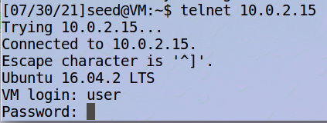

Sniffer output:

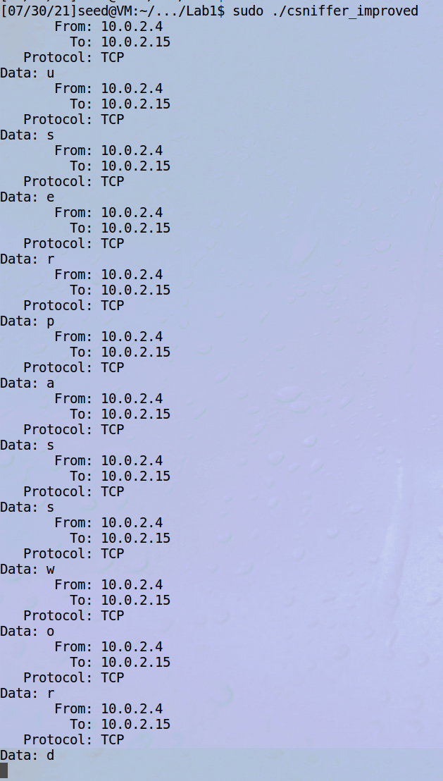

**Task 2.2A – Write a spoofing program:**

Code for this section was taken and spliced together from class files, with pertinent parts here:

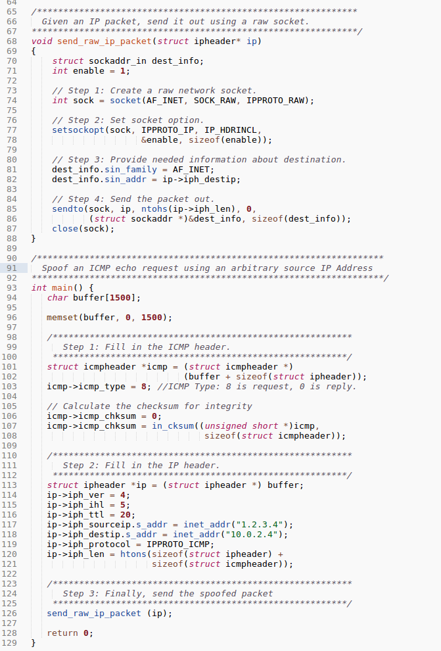

Output of the other VM’s Wireshark when its partner hits it with spoofed traffic using the program above:



Observations: We can see that the spoofing works here, since the ping request makes it successfully to the target from our VM, but the source address of the packet is garbage and conceals the real sender. A side effect of this is that the actual sender does not get the echo response, but instead an ICMP packet that informs us that the response could not be sent.

**Task 2.2B – Spoof ICMP Echo Request**

Code change here was very slight – updated the source IP to a real IP address (in this case 8.8.8.8). I still observed from the machine that was requested for by the spoofing VM:

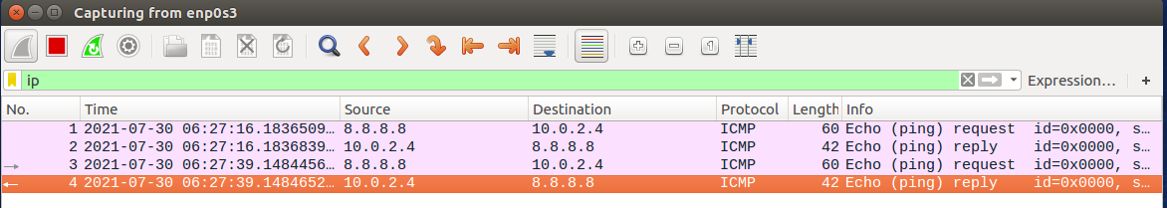

**Observations**: We can see that the target VM believes it has received a ping request from 8.8.8.8 and responds accordingly. Nowhere is the IP of the actual machine (10.0.2.15) seen.

**Question 1:** You can set the packet length as large as you want, within the size constraint of the datatype that holds the value (16bits).

**Question 2:** The OS should take care of calculating the checksum for IP headers even with raw sockets, but we can also do it manually as the lab’s code demonstrates.

**Question 3:** We need the root privilege to run the spoofer because we need to be allowed to open our own raw sockets to send from. Without root privilege, the program fails at the socket function, which is where we create the raw socket directly.

**Task 2.3 – Sniff and then Spoof:**

Code to do snoofing (a virtual perfect copy of the sniffing and spoofing programs together):

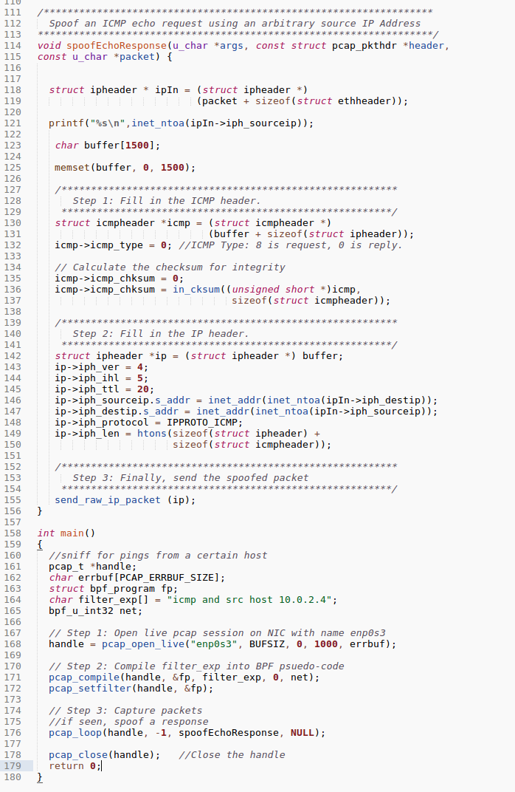

Result from the other VM when pinging a dead IP with the snoofer OFF:



Result from the other VM when pinging a dead IP with the snoofer ON:



Observation: We prove that with the snoofer off, dead IP addresses are not able to be pinged successfully from the perspective of the pinging host. With the snoofer on, Wireshark shows that the ping request got a full response, and it appears to be from the fake source, not the VM that the spoofer is running on. This particular use case is fairly benign, but it is easy to see how this technique could be used in a much more complex or nefarious way.

Comments: It was pretty surprising how easy this final step was, given the previous work to get the other components up and running. I just refactored the spoofing component to be a function rather than main and then used the main from the sniffing program in the snoofer main.